- Get all this solved on EKS

Amazon EKS Cluster Setup

Prerequisites
On WSL (Windows Subsystem for Linux), install the following tools:
- AWS CLI
- kubectl
- eksctl
Verify that all tools are installed successfully.

Amazon EKS Cluster Creation
- Create a single YAML configuration file to provision an Amazon EKS cluster.
- Configure the cluster with:
  - 2 Worker Nodes
- Create the EKS cluster using the YAML configuration file.
==================================================================
1: Download AWS CLI
#curl "https://awscli.amazonaws.com/awscli-exe-linux-x86_64.zip" -o "awscliv2.zip"

#unzip awscliv2.zip
#./aws/install
#aws –version
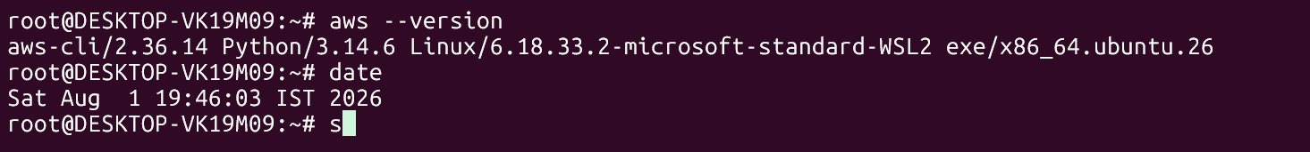
2: Configure AWS CLI to access from WSL
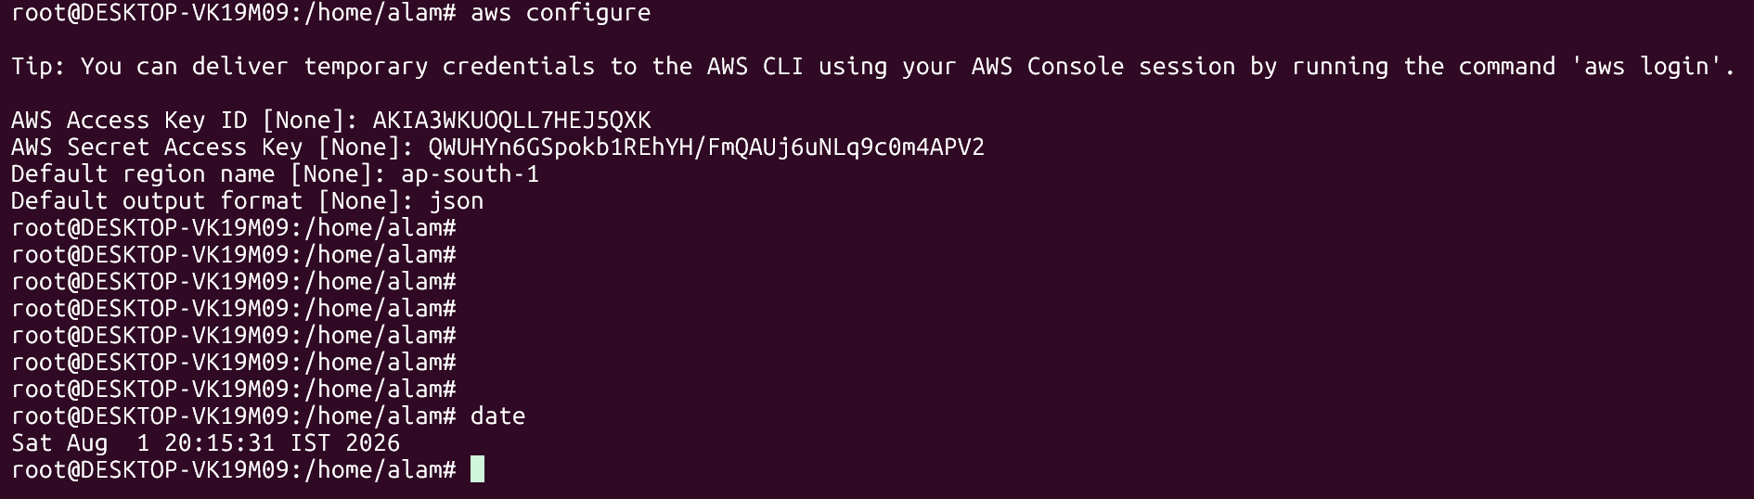
#aws sts get-caller-identity -----aws sts get-caller-identity AWS CLI ki ek command hai jo batati hai ki abhi aap kis AWS identity (user ya role) se authenticated ho.
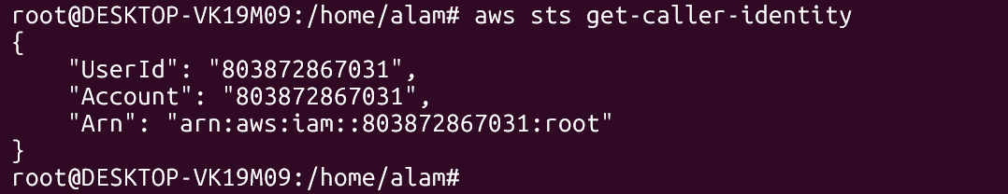
3: kubectl verification
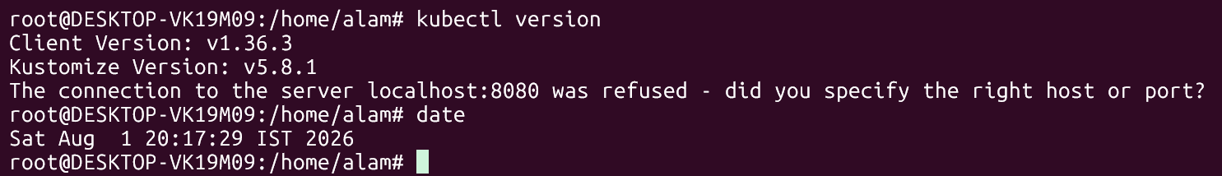
4: Install eksctl
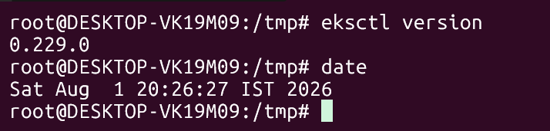

my-first-eks-cluster.yaml with 2 node cluster, with min size 2 and max size 2
apiVersion: eksctl.io/v1alpha5
kind: ClusterConfig

metadata:
name: my-first-eks-cluster
region: ap-south-1
version: "1.33"

managedNodeGroups:
- name: worker-nodes
instanceType: t3.micro
desiredCapacity: 2
minSize: 2
maxSize: 2

volumeSize: 20

ssh:
allow: true

labels:
role: worker

tags:
Environment: Demo

#Create the EKS cluster
#eksctl create cluster -f my-first-eks-cluster.yaml

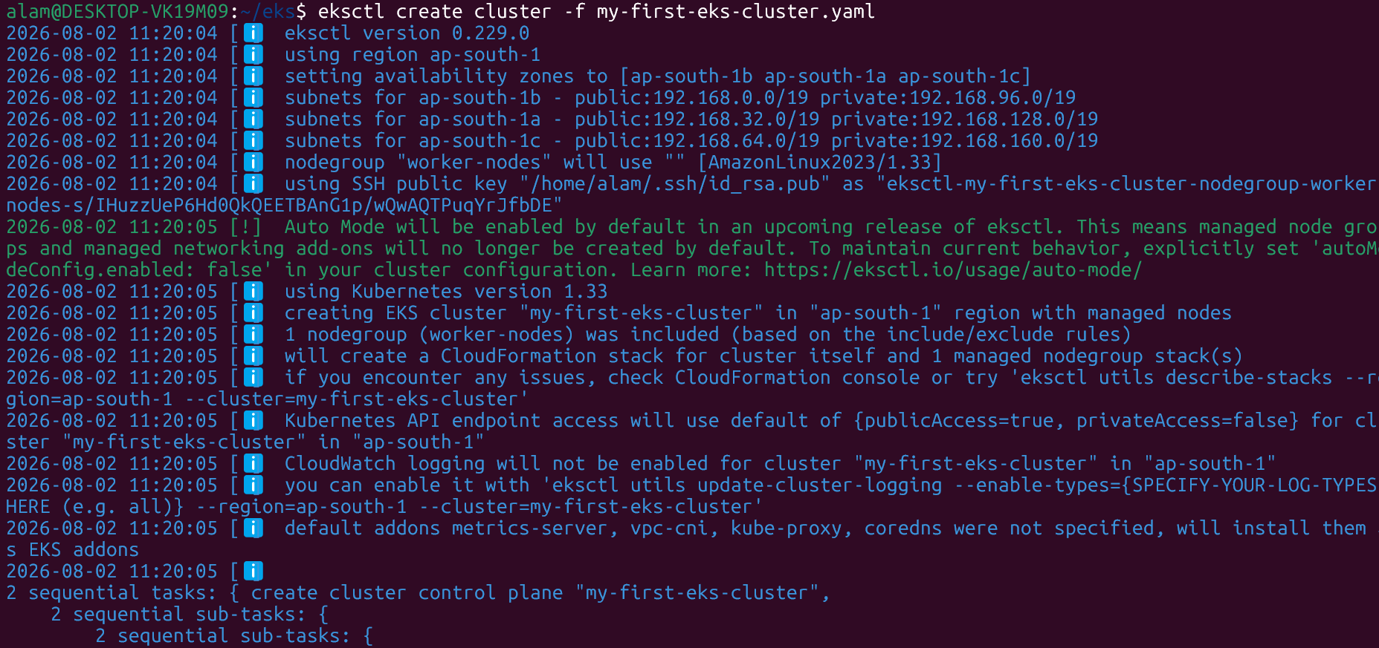

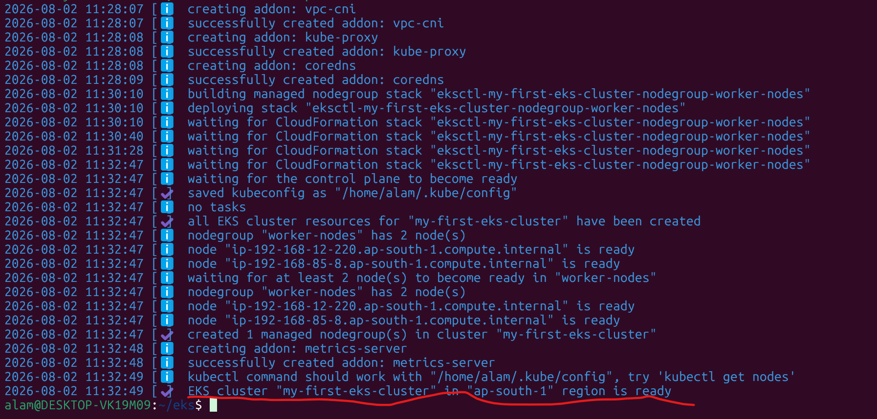

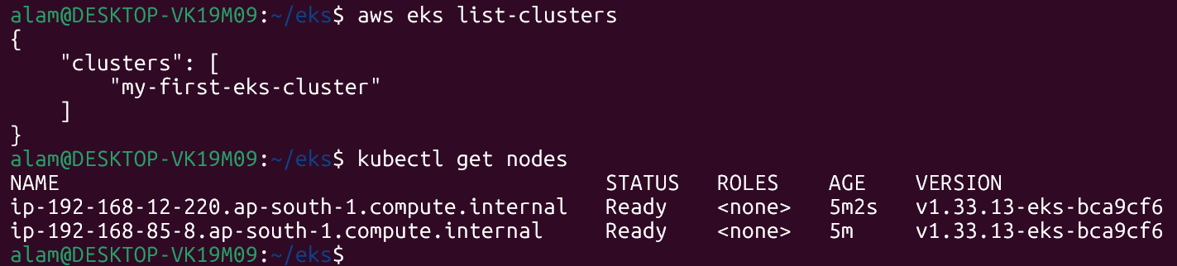



Delete the EKS cluster
Use:
eksctl delete cluster --name my-first-eks-cluster --region ap-south-1
or if you still have your YAML file:
eksctl delete cluster -f my-first-eks-cluster.yaml

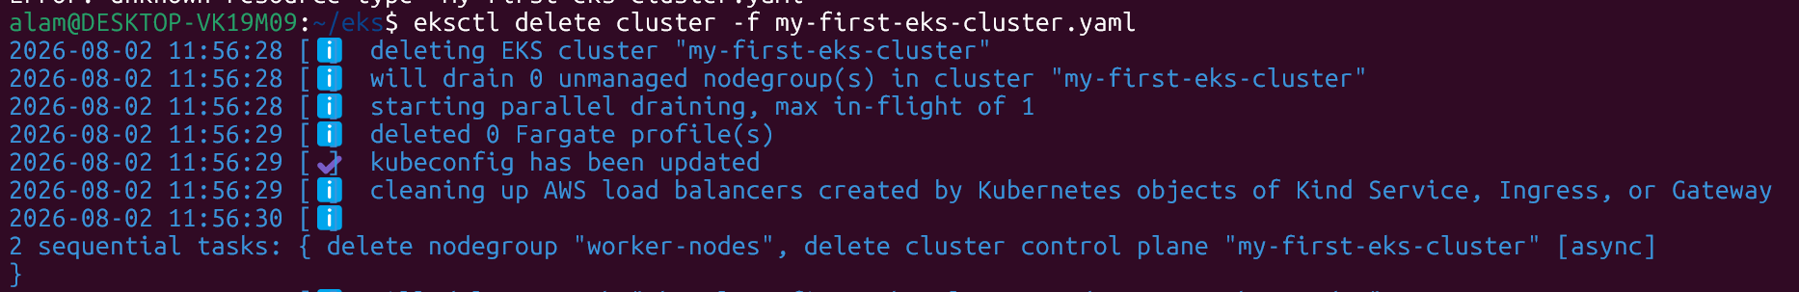

Connect to the EKS Cluster
- Update the local kubeconfig file using the AWS CLI.
# aws eks update-kubeconfig --region ap-south-1 --name my-first-eks-cluster
This will updates your local kubeconfig file so that kubectl can connect to your Amazon EKS (Elastic Kubernetes Service) cluster.
- Verify connectivity to the EKS cluster using kubectl.
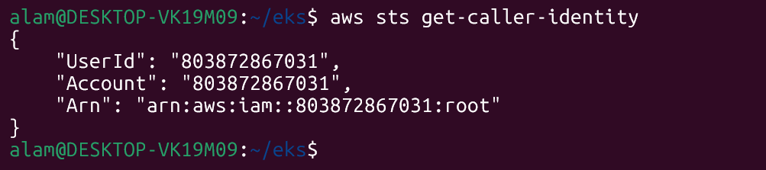
"UserId": "803872867031",
"Account": "803872867031",
"Arn": "arn:aws:iam::803872867031:root"
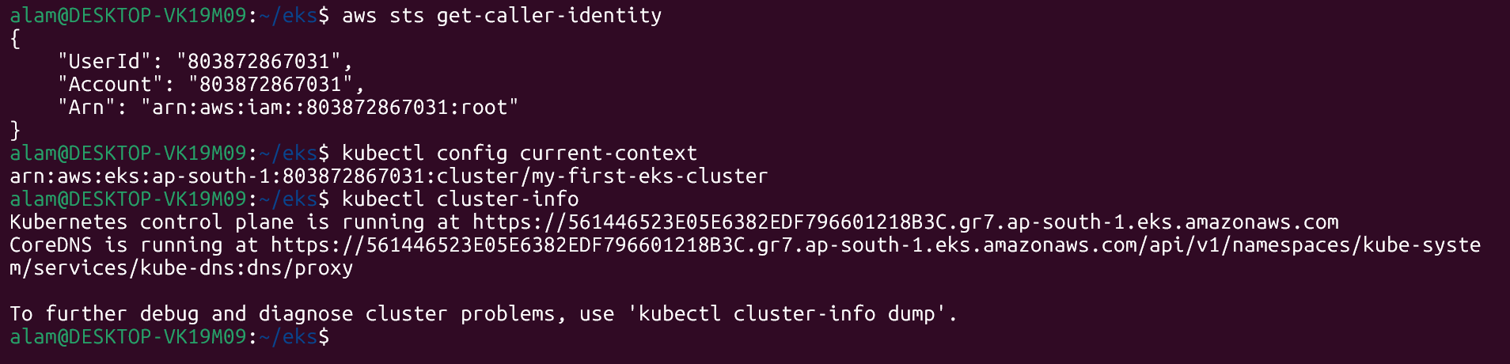
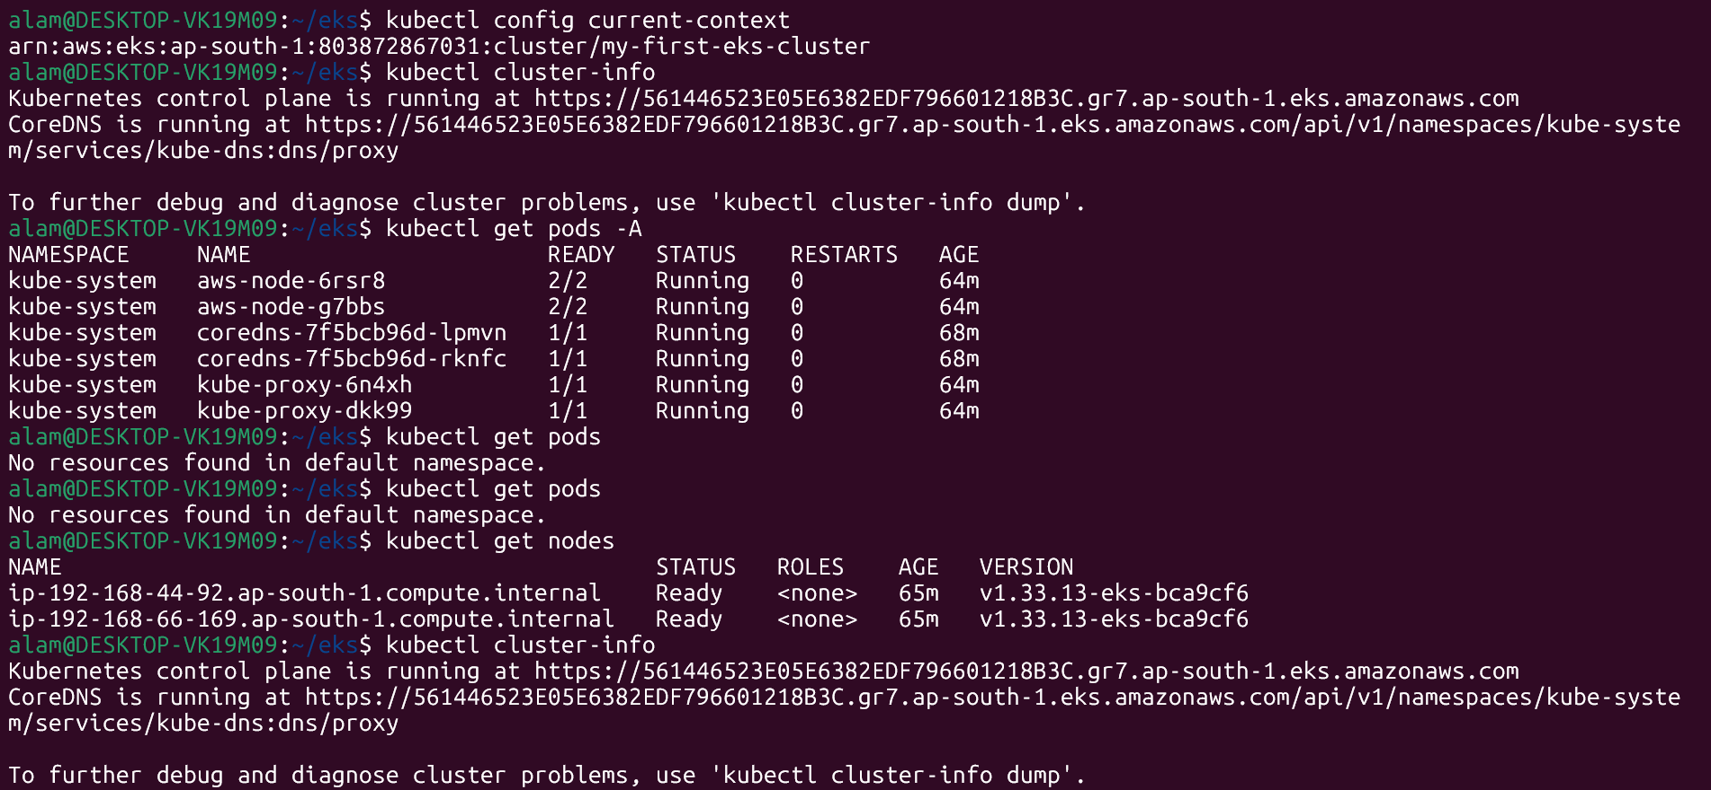
If kubectl get nodes returns your cluster's nodes and kubectl cluster-info shows the Kubernetes API server endpoint, your WSL environment is successfully connected to the EKS cluster. Refer above screen shots.
- Confirm that all nodes are in the Ready state.
